STARAGILE ANSIBLE ASSIGNMENT -2

1. **Create 2 AWS Ubuntu Instances**:

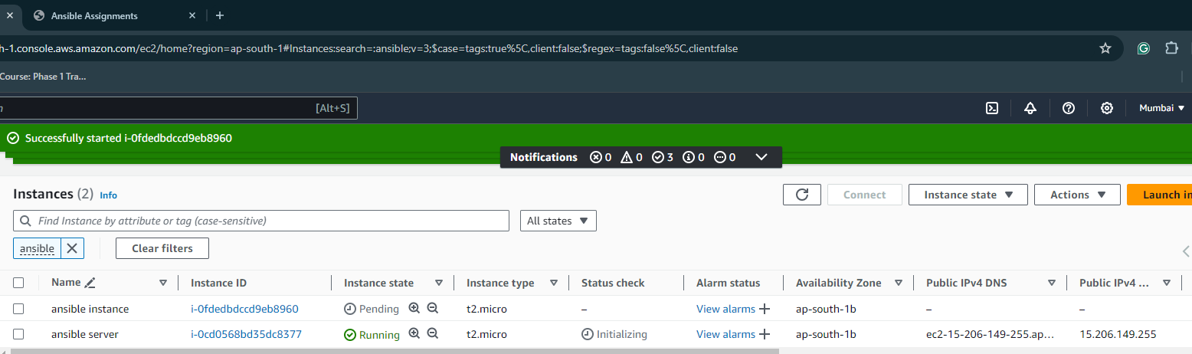

1. **Setup Ansible on one instance**:

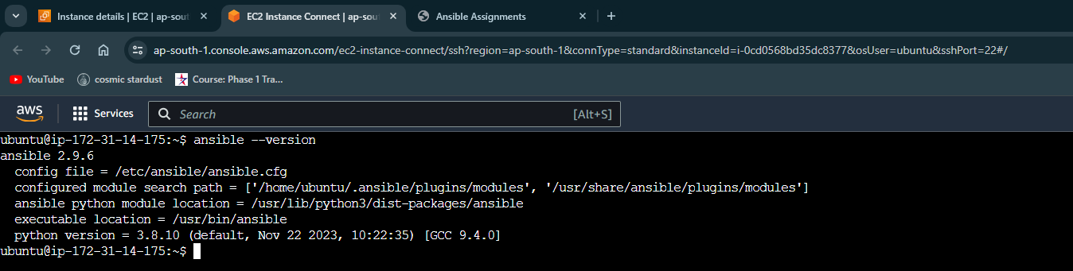

1. **Setup Hosts Inventory File**:

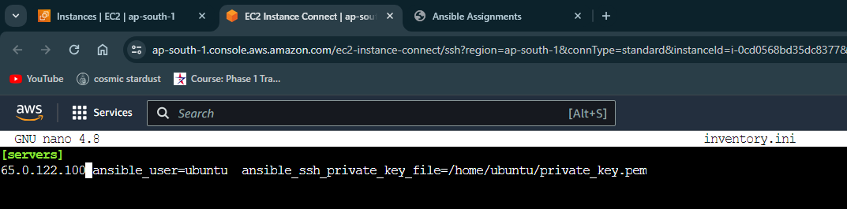

1. **Take the Spring Boot Application**:

Clone the Spring Boot application

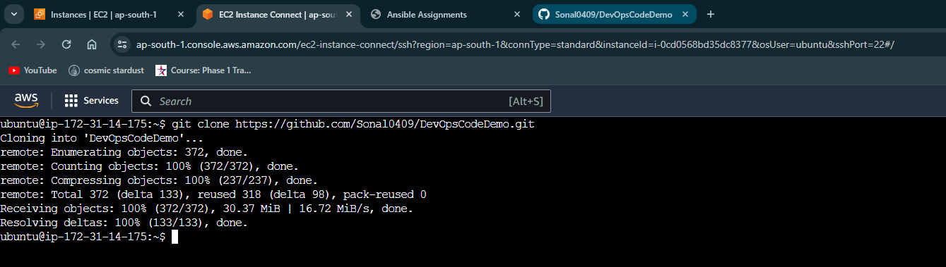

Install maven

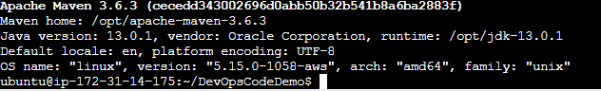

Build the application using Maven

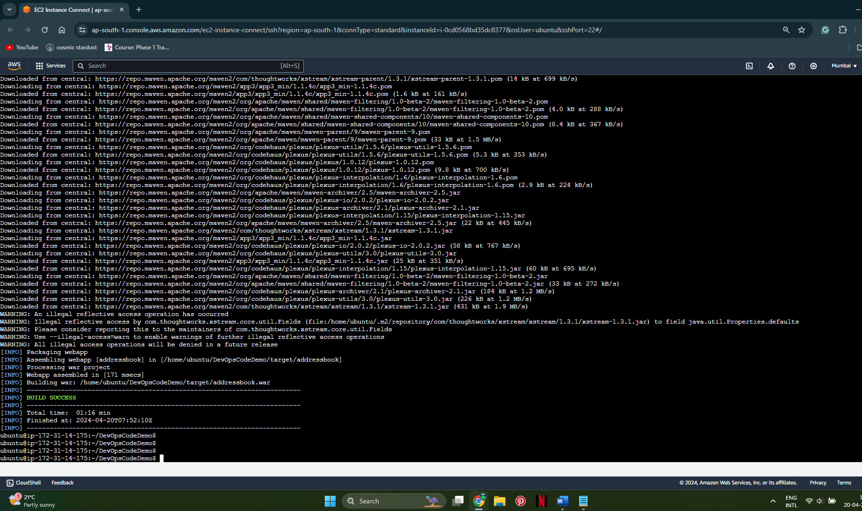

1. **Containerize the Spring Boot Application**:

**Install docker**

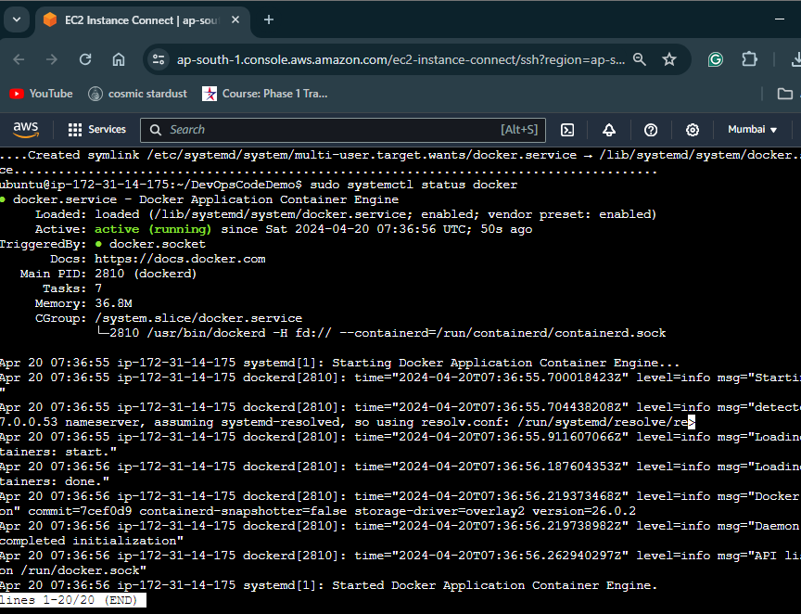

Write a Dockerfile

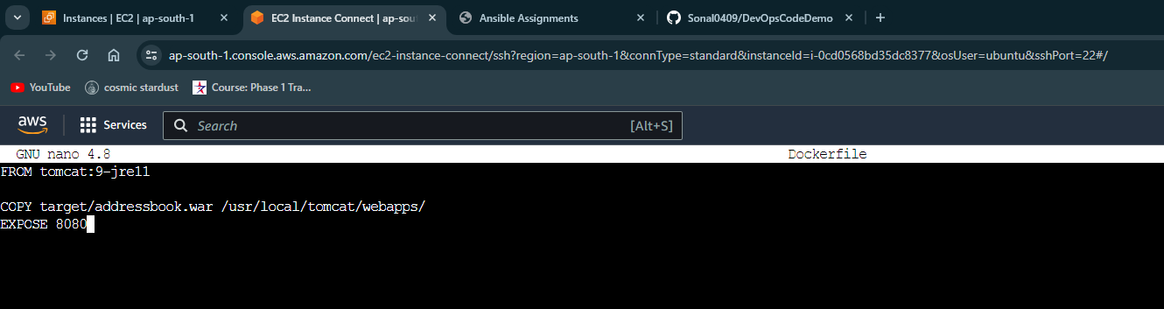

Build the Docker image

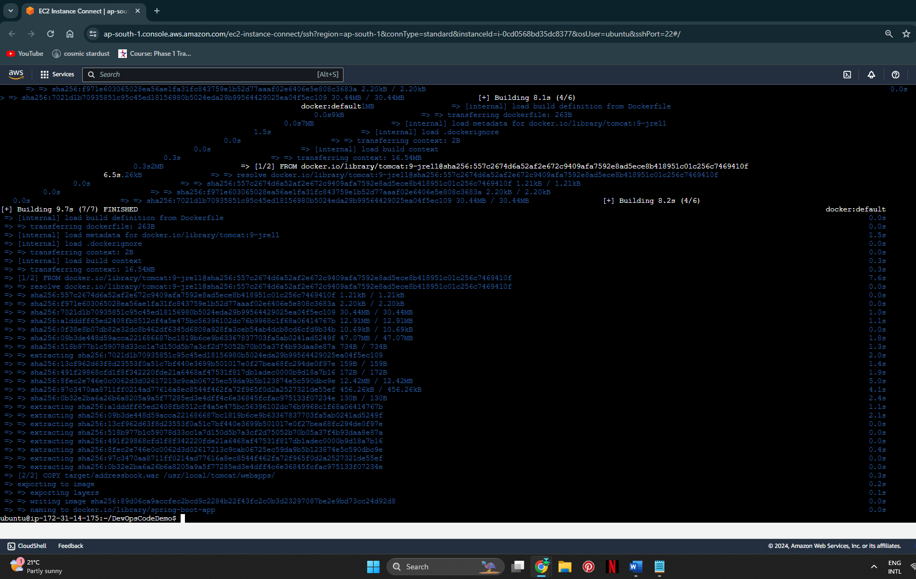

Run the docker image

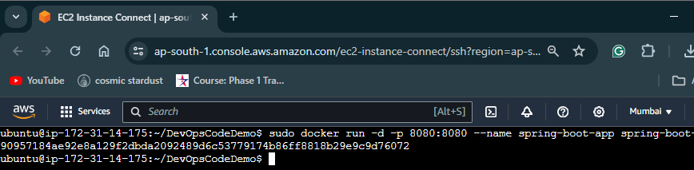

Push the Docker image to Docker Hub:

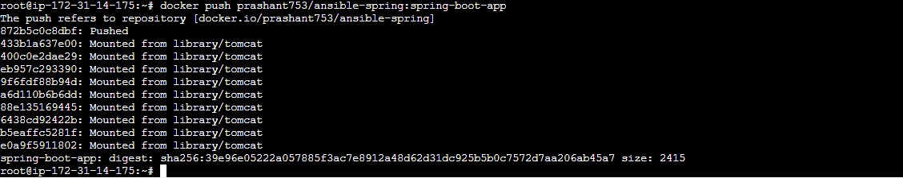

1. **Write an Ansible Role**:

Create an Ansible role



Define tasks in the main.yml

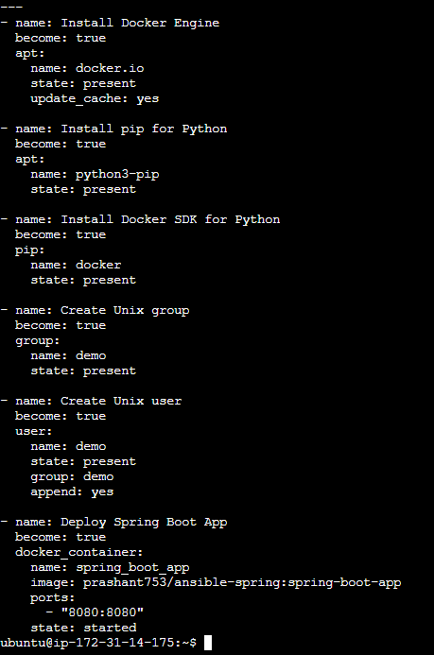

1. **Write a Playbook**:

Create a playbook **deploy.yml**

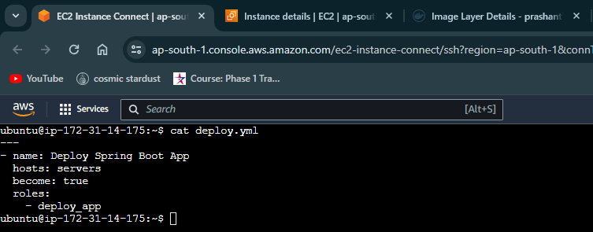

1. **Run the Playbook**:

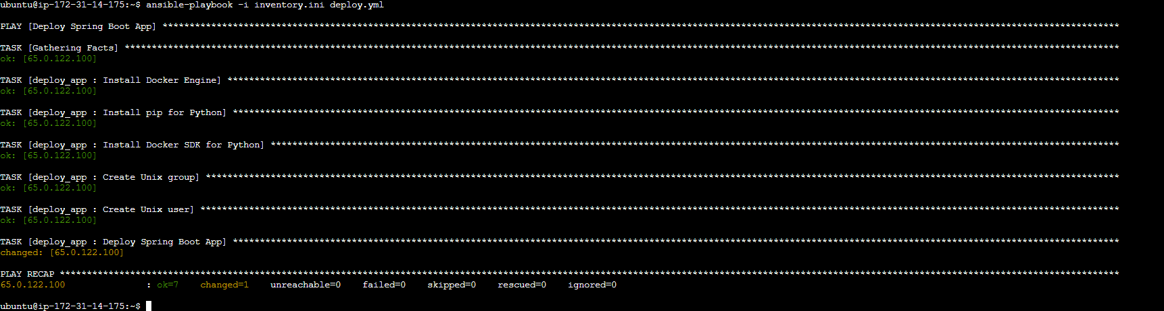

1. **Verify the Application**:

Access the application in the browser using the public IP address of the instance where the Spring Boot app is deployed using ansible

